# COMP 7500/7506-Lecture02: Interprocess Communication

**🟊: >85%, 🟊🟊: 70-85%, 🟊🟊🟊: 55-70%, 🟊🟊🟊🟊: 40-55%, 🟊🟊🟊🟊🟊: < 40%**

**🟊🟊🟊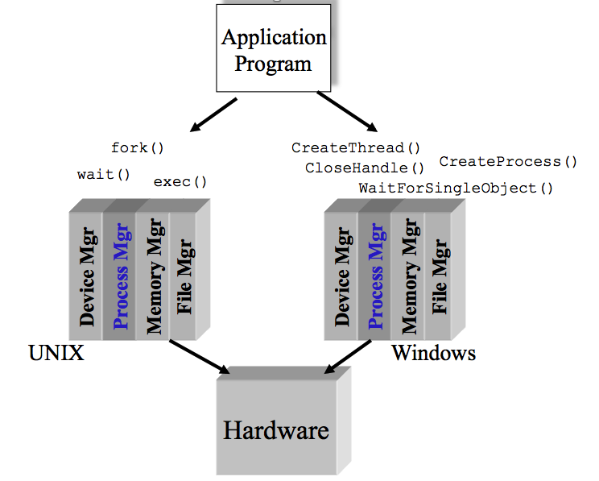 Exercise 1 (Menti):** Which one of the following is **not** a basic component in Microkernel? (30 seconds)

1. Process manager
2. Memory manager
3. IPC: inter-process communications
4. File manager

**🟊🟊🟊🟊 Exercise 2 (Menti):** Which one of the following items is **not** a design goal of a process manager? Hint: You should focus on OS management of application execution. (30 seconds)

1. To improve CPU utilization
2. To switch a processor among multiple processes
3. To allocate memory resources to processes
4. To use processor more efficiently

**🟊🟊 Exercise 3 (Menti):** The context-switch time is OS overhead. The context-switch overhead depends on the following factors **except**. (30 Seconds)

1. The complexity of the OS and PCB B. Open source operating systems
2. Multiple sets of registers per CPU D. Multiple contexts loaded at once

**Exercise 4:** What are advantages of process cooperation (30 Seconds)?

**🟊🟊🟊 Exercise 5:** What can be a potential problem if all the four tabs in a chrome browser are running in a single process? (1 Minutes)?

**🟊🟊🟊🟊🟊 Exercise 6:** Can you design a multiprocess architecture to solve problem described in Exercise 5? **Hint:** There are three types of cooperating processes

**🟊🟊🟊 Exercise 7:** What are two fundamental models of interprocess communication? **Hint:** How do two process talk with each other?

**🟊🟊🟊 Exercise 8 (Menti):** Suppose two processes are exchanging a small amount of data, which interprocess communication model will you choose? Why? (30 Seconds)

1. Shared Memory
2. Shared Buffer
3. Message Passing
4. Message Chatting

**🟊🟊 Exercise 9 (Menti):** Which interprocess communication model is faster than its counterpart? **Assumption:** message-passing systems are implemented using system calls; shared-memory systems are implemented in the OS kernel. (30 Seconds)

1. Message Passing is faster
2. Shared Memory is faster
3. Shared Message is faster
4. Two models are both fast

**🟊🟊🟊 Exercise 10 (Menti):** Which interprocess communication model is easier to implement in a distributed system? (30 Seconds)

1. **A picture containing indoor, table, wall

   Description generated with very high confidence**Shared Memory is easier
2. Message Passing is faster
3. Message Passing is easier
4. Two models are equally easy